How To Grow/Care For Paperwhites
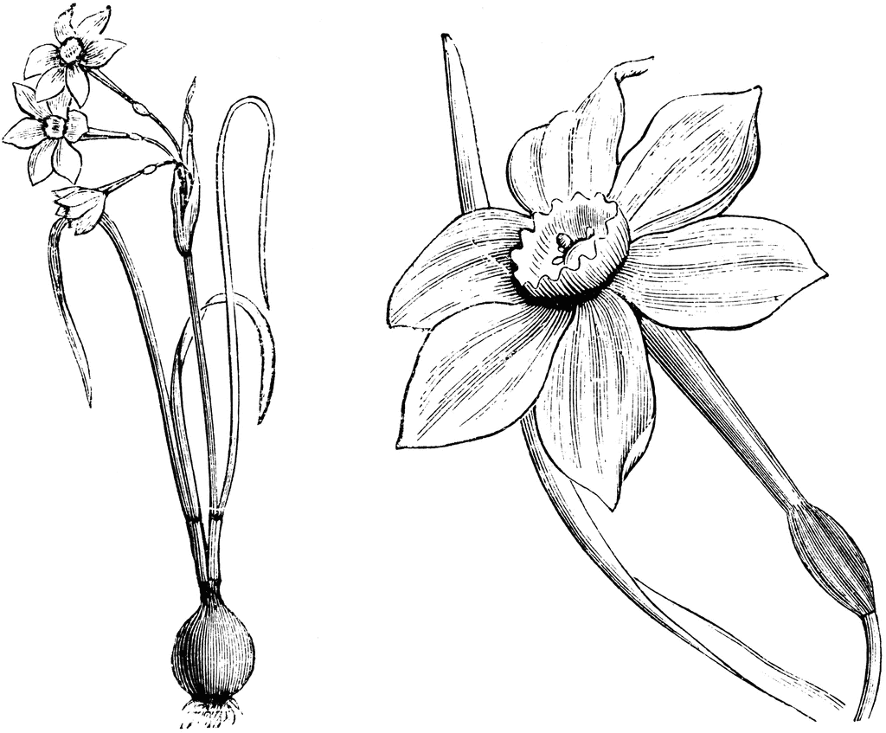
Fill container with pebbles.
Nestle each bulb slightly into the stones so they are stable and add a few extra stones around the edges.
Add water until the very bottom of the bulb is wet, but no more as the bulbs will rot.
Place bulbs in a sunny window. Add water when needed.
Roots will appear in 1-2 weeks. Blooms will appear in 3 to 4 weeks.

How To Grow/Care For Paperwhites
Fill container with pebbles.
Nestle each bulb slightly into the stones so they are stable and add a few extra stones around the edges.
Add water until the very bottom of the bulb is wet, but no more as the bulbs will rot.
Place bulbs in a sunny window. Add water when needed.
Roots will appear in 1-2 weeks. Blooms will appear in 3 to 4 weeks.
How To Grow/Care For Paperwhites
Fill container with pebbles.
Nestle each bulb slightly into the stones so they are stable and add a few extra stones around the edges.
Add water until the very bottom of the bulb is wet, but no more as the bulbs will rot.
Place bulbs in a sunny window. Add water when needed.
Roots will appear in 1-2 weeks. Blooms will appear in 3 to 4 weeks.

How To Grow/Care For Paperwhites
Fill container with pebbles.
Nestle each bulb slightly into the stones so they are stable and add a few extra stones around the edges.
Add water until the very bottom of the bulb is wet, but no more as the bulbs will rot.
Place bulbs in a sunny window. Add water when needed.
Roots will appear in 1-2 weeks. Blooms will appear in 3 to 4 weeks.

